C++ standard committee added the Standard Template Library (STL) to the C++ Standard Library. The STL defines powerful, template-based, reusable components that implement many common data structures and algorithms used to process those data structures.

COMPONENTS OF STL
STL contains three key components—containers (popular templatized data structures), iterators and algorithms. The STL containers are data structures capable of storing objects of almost any data. Each STL container has associated member functions. A subset of these member functions is defined in all STL containers.

STL iterators, which have properties similar to those of pointers, are used by programs to manipulate the STL-container elements.

STL algorithms are functions that perform such common data manipulations as searching, sorting and comparing elements (or entire containers). The STL provides approximately 70 algorithms. Most of them use iterators to access container elements.

CONTAINERS
Containers can be described as the objects that hold the data of the same type. Containers are used to implement different data structures for example arrays, list, trees, etc.

Classification of containers : The containers are divided into three major categories—sequence containers, associative containers and container adapters/Derived containers.
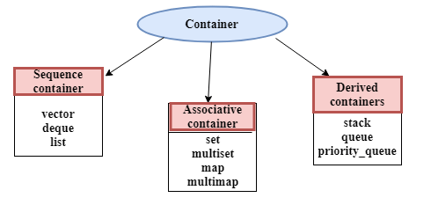

sequence containers: The sequence containers represent linear data structures, such as vectors and linked lists.

associative containers: Associative containers are nonlinear containers that typically can locate elements stored in the containers quickly. Such containers can store sets of values or key/value pairs.

The sequence containers and associative containers are collectively referred to as the first-class containers.

container adapters : Stacks and queues actually are constrained versions of sequential containers. For this reason, STL implements stacks and queues as container adapters that enable a program to view a sequential container in a constrained manner.

Following are the containers that give the details of all the containers as well as the header file and the type of iterator associated with them :

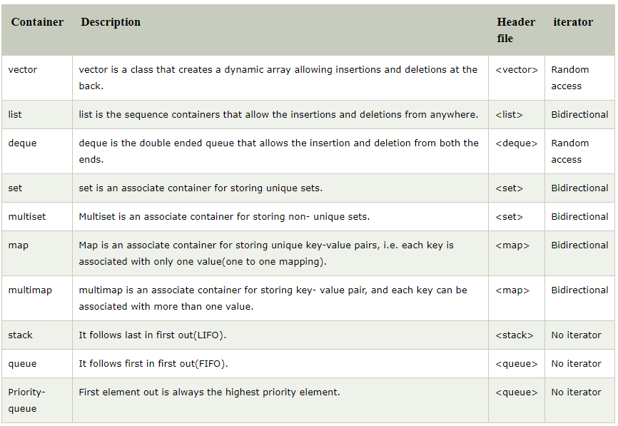

Introduction to Iterators

Iterators have many features in common with pointers and are used to point to the elements of first-class containers. Iterators are used to traverse from one element to another element, a process is known as iterating through the container. The main advantage of an iterator is to provide a common interface for all the containers type. Iterators provide a generic approach to navigate through the elements of a container.

Syntax
<ContainerType> :: iterator;

Operations Performed on the Iterators:

- Operator (*) : The '*' operator returns the element of the current position pointed by the iterator.
- Operator (++) : The '++' operator increments the iterator by one. Therefore, an iterator points to the next element of the container.
- Operator (==) and Operator (!=) : Both these operators determine whether the two iterators point to the same position or not.
- Operator (=) : The '=' operator assigns the iterator.

Difference b/w Iterators & Pointers
Iterators can be smart pointers which allow to iterate over the complex data structures. A Container provides its iterator type. Therefore, we can say that the iterators have the common interface with different container type. Iterators play a critical role in connecting algorithm with containers along with the manipulation of data stored inside the containers. The container classes provide two basic member functions that allow to iterate or move through the elements of a container:
- begin(): The begin() function returns an iterator pointing to the first element of the container.
- end(): The end() function returns an iterator pointing to the past-the-last element of the container.
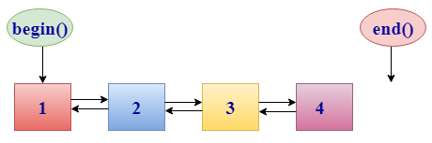

Iterator Categories
An iterator can be categorized in the following ways:
- Input Iterator
- Output Iterator
- Forward Iterator
- Bidirectional Iterator
- Random Access Iterator
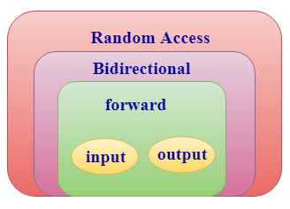
- Input iterator:
  - An Input iterator is an iterator that allows the program to read the values from the container.
  - Dereferencing the input iterator allows us to read a value from the container, but it does not alter the value.
  - An Input iterator is a one way iterator.
  - An Input iterator can be incremented, but it cannot be decremented.
- Output iterator:
  - An output iterator is similar to the input iterator, except that it allows the program to modify a value of the container, but it does not allow to read it.
  - It is a one-way iterator.
  - It is a write only iterator.
- Forward iterator:
  - Forward iterator uses the ++ operator to navigate through the container.
  - Forward iterator goes through each element of a container and one element at a time.
- Bidirectional iterator:
  - A Bidirectional iterator is similar to the forward iterator, except that it also moves in the backward direction.
  - It is a two way iterator.
  - It can be incremented as well as decremented.
- Random Access Iterator:
  - Random access iterator can be used to access the random element of a container.
  - Random access iterator has all the features of a bidirectional iterator, and it also has one more additional feature, i.e., pointer addition. By using the pointer addition operation, we can access the random element of a container.
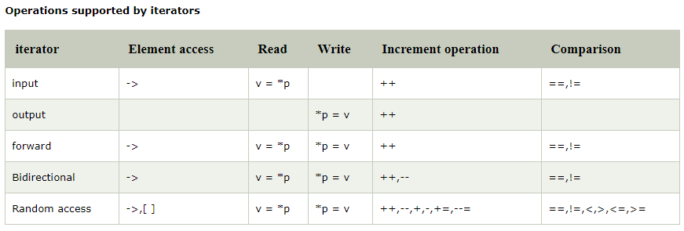

Introduction to Algorithms

STL algorithms can be used generically across a variety of containers. STL provides many algorithms to manipulate containers. Inserting, deleting, searching,
sorting and others are appropriate for some or all of the STL containers. The STL includes approximately 70 standard algorithms. The algorithms operate on container elements only indirectly through iterators. Algorithms often return iterators that indicate the results of the algorithms.

STL algorithms can be categorized as:

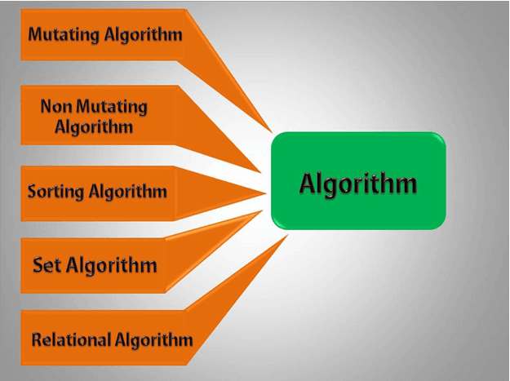

- Mutating algorithms: Mutating algorithms are the algorithms that can be used to alter the value of a container. They can also be used to change the order of the elements in which they appear.

- Nonmutating algorithms: Nonmutating algorithms are the algorithms that do not alter any value of a container object nor do they change the order of the elements in which they appear. These algorithms can be used for all the container objects, and they make use of the forward iterators.

- Sorting algorithms: Sorting algorithms are the modifying algorithms used to sort the elements in a container.

- Set algorithms: Set algorithms are also known as sorted range algorithm. This algorithm is used to perform some function on a container that greatly improves the efficiency of a program.

- Relational algorithms: Relational algorithms are the algorithms used to work on the numerical data. They are mainly designed to perform the mathematical operations to all the elements in a container.

Vector
A vector is a sequence container class that implements dynamic array, means size automatically changes when appending elements. A vector stores the elements in contiguous memory locations and allocates the memory as needed at run time.

Difference between vector and array
An array follows static approach, means its size cannot be changed during run time while vector implements dynamic array means it automatically resizes itself when appending elements.

Syntax
Consider a vector 'v1'. Syntax would be:
vector<object_type> v1;
vector<type>v1(5)
vector<type>v1(5,100)
Ex. 1
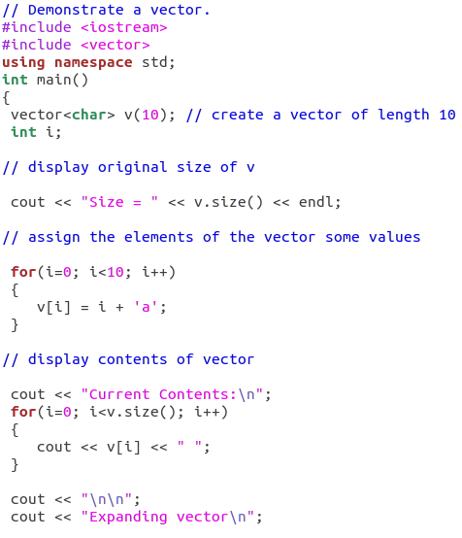
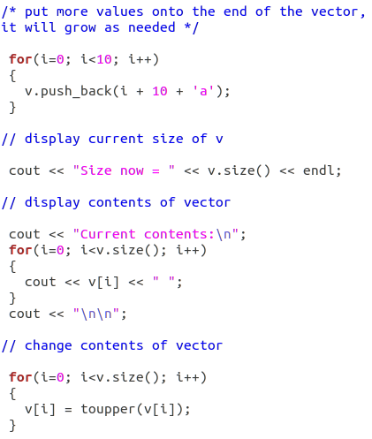
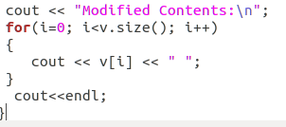
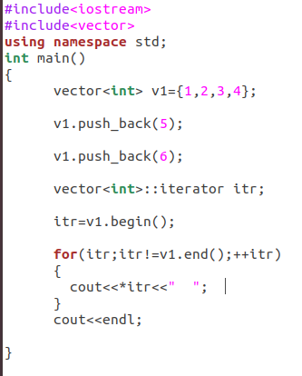

Vector Functions

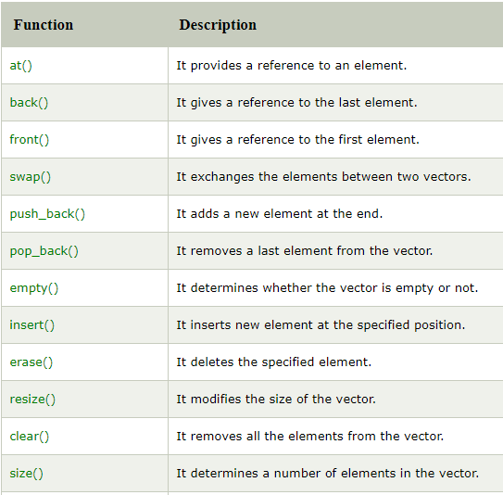
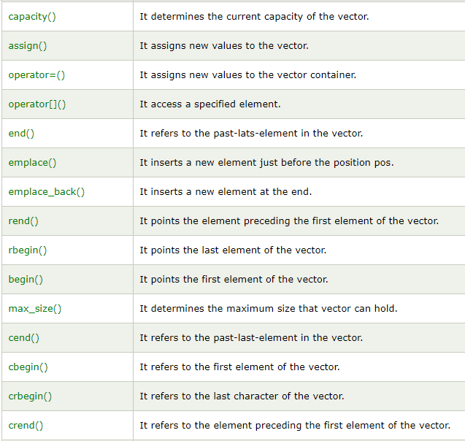
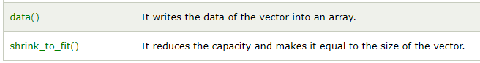

Ex 2
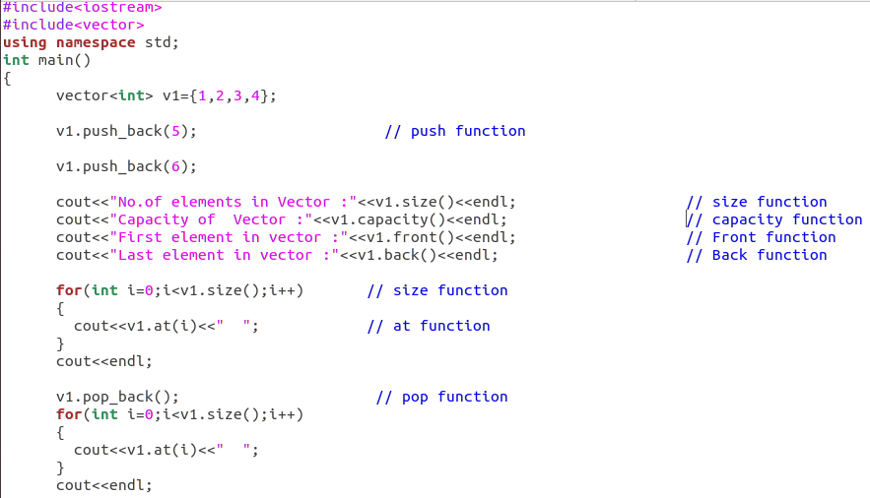
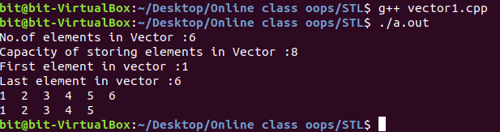

List

The list sequence container provides an efficient implementation for insertion and deletion operations at any location in the container. Insertion and deletion in the middle of the vector is very costly as it takes lot of time in shifting all the elements. Linklist overcome this problem and it is implemented using list container. List supports a bidirectional and provides an efficient way for insertion and deletion operations. Traversal is slow in list as list elements are accessed sequentially while vector supports a random access.

Syntax
Consider a list 'L'. Syntax would be:
list<object_type> L;

List can be initialised in two ways.
list<int> new_list{1,2,3,4};
or
list<int> new_list = {1,2,3,4};

C++ List Functions
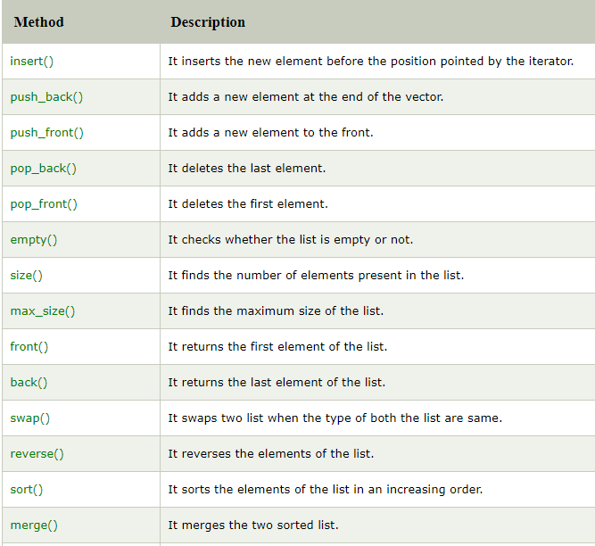
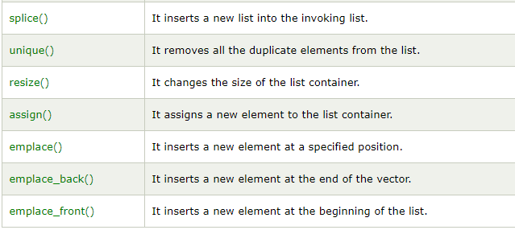
Example:
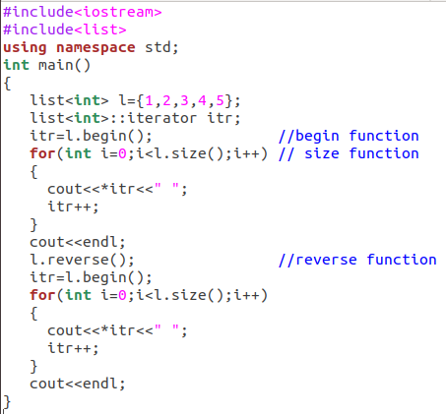
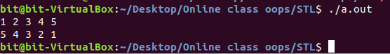

map Associative Container
Maps are associative containers that store elements in a mapped fashion. Each element has a key value and a mapped value. No two mapped values can have same key values. For example, a company that uses unique employee numbers, such as 100, 200 and 300, might have a map that associates employee numbers with their telephone extensions—4321, 4115 and 5217, respectively. With a map you specify the key and get back the associated data quickly. A map is also known as an associative array. Providing the key in a map’s subscript operator [] locates the value associated with that key in the map. Insertions and deletions can be made anywhere in a map.
In a map, the key values are generally used to sort and uniquely identify the elements, while the mapped values store the content associated to this key. The types of key and mapped value may differ, and are grouped together in member type value_type, which is a pair type combining both:

Syntax
map<key_type , value_type> map_name;

Member Functions
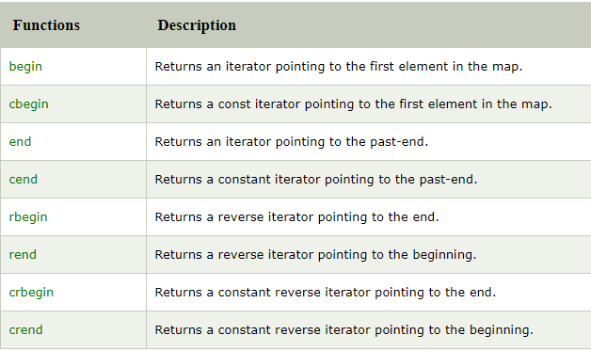
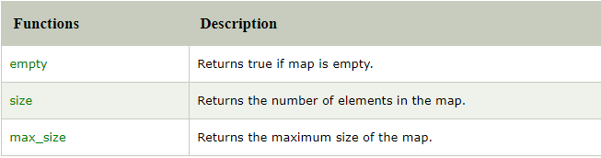
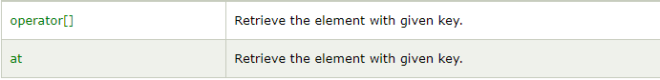
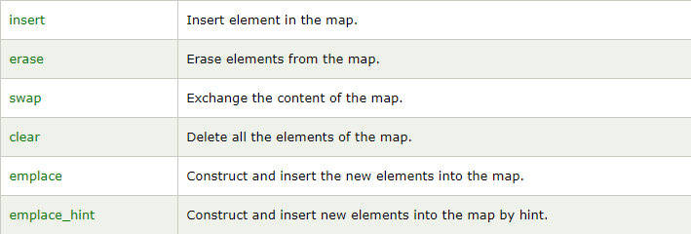

EX.
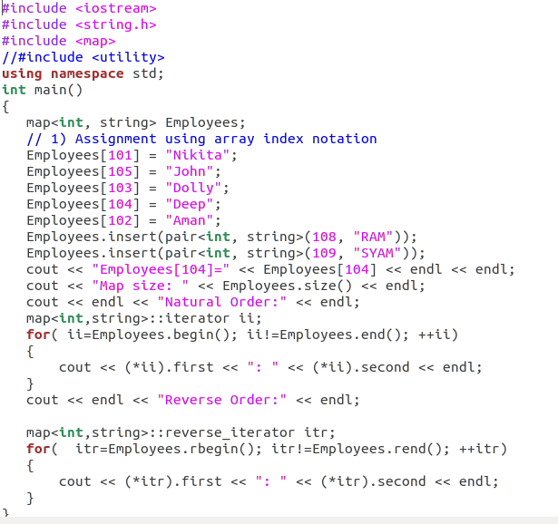

Output:
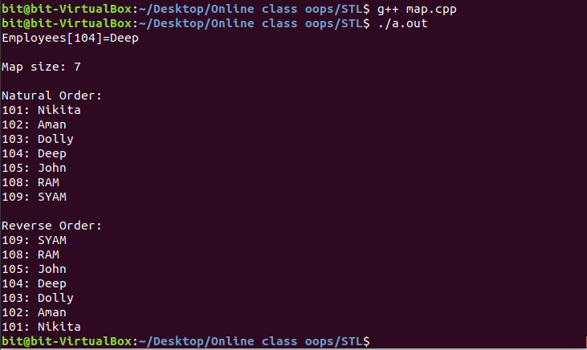

Stack Adapter
The STL provides three container adapters—stack, queue and priority_queue. Adapters are not first-class containers, because they do not provide the actual data-structure implementation in which elements can be stored and because adapters do not support iterators. The benefit of an adapter class is that you can choose an appropriate underlying data structure.

Class stack enables insertions into and deletions from the underlying data structure at one end (commonly referred to as a last-in, first-out data structure). A stack can be implemented with any of the sequence containers: vector, list and deque.

Stack Syntax:-
For creating a stack, we must include the <stack> header file in our code. We then use this syntax to define the std::stack:
template <class Type, class Container = deque<Type> > class stack;
Type – is the Type of element contained in the std::stack. It can be any valid C++ type or even a user-defined type.

Container – is the Type of underlying container object.

The functions associated with stack are:
empty() – Returns true if the invoking stack is empty and false otherwise
size() – Returns the size of the stack.
top() – Returns a reference to the top most element of the stack.
push(g) – Adds the element ‘g’ at the top of the stack.
pop() – Deletes the top most element of the stack

